**ONLINE RESTAURANT MANAGEMENT SYSTEM**

PROJECT BY: VISHAKA PAHUJA & MUSKAN NARANG //VISHAN

## RESTAURANT MANAGEMENT WEB APPLICATION

**INTRODUCTION**

"Online Restaurant Management System" is a web application. This web application is developed to automate day to day activity of a restaurant. Restaurant is a kind of business that serves people all over world with ready-made food. This web application is developed to provide service facility to restaurant`s owner and also to the customer. This restaurant management web application can be used in the restaurants to facilitate when there is less number of employees. With the help of this application, customers can order whatever they want to eat without any difficulty. The services that are provided is food ordered by the customer through application that is fixed in table, menu information management and report. The restaurant menu is organized by categories (Starters, Soups & Salads, Family Platters, Deserts and Drinks) of menu items. Main objective to build the web application is to decrease the cost of restaurants and this application will be plus point for any restaurant, as we are living in time period of technology. Each menu item has a name and price. After successful login the customer can access the menu page with the items listed. The main point of developing this system is to help restaurant administrator manage the restaurant business and help customer for ordering and reserve table.

At Management side, initially the staff member has to login, for login:

THE USERNAME IS:

VISHAN //you can use capital or small letters

THE PASSWORD IS:

1000

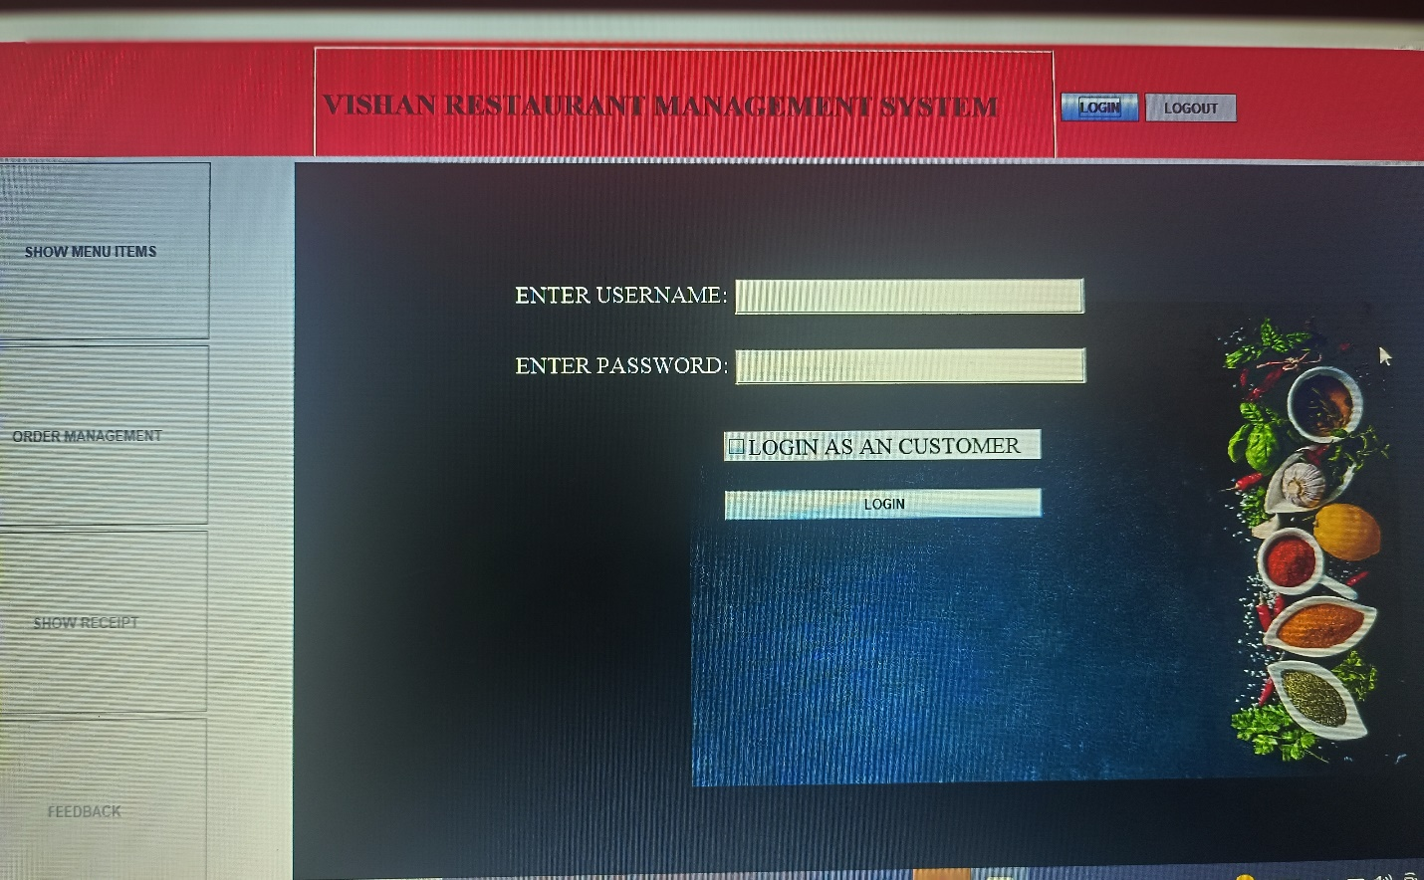

**PROJECT LIBRARIES**

1. **import javax.swing.*;**
2. **import java.awt.*;**
3. **import java.awt.event.ActionEvent;**
4. **import java.awt.event.ActionListener;**
5. **import java.io.File;**
6. **import java.io.FileWriter;**
7. **import java.util.*;**

**Module of the restaurant management system**

**Customer Online Ordering & Reservation Module**

Through customer ordering and reservation module you will be able to order quickly and that time you can also check the total bill.

**Feedback Module**

Based on food or everything about the restaurant, customer can give any suggestion or comment to the restaurant with feedback card. From this card, side of restaurant will know their weaknesses and strengths.

**Menu &order Module**

Menu module is food that restaurant prepared for customer. This module, customer can view the menu and make decision for order.